Intra and inter-personal coordination: Wrist pendulum swinging paradigm
In this lab, we will explore the dynamics of coordination between two arms while trying to achieve perfect in-phase and perfect anti-phase coordination intentionally. We will then repeat the same coordination task in pairs.

Demo 1: Within-person coordination
A typical dependent measure variable to describe the stability of coordination is called the “relative phase”. It is calculated as the difference in the phase of each oscillator sketched below:
Question 1) As we discussed in class, there are two spontaneously preferred coordination patterns. In-phase and anti-phase. Describe what these patterns are when you swing a rod in your hand. Imagine holding two sticks in each hand and swinging them in the direction away and toward your body using your wrists (ulnar deviation – radial deviation movement).
_____________________________________________________________________________________
_____________________________________________________________________________________
_____________________________________________________________________________________
_____________________________________________________________________________________
____________________________________________________________________________________

Question 2) Hypothesis: Make a prediction about the effects of movement speed (frequency of pendulum oscillation) and nature of coordination (in- vs. anti-phase) on the stability of coordination.
_____________________________________________________________________________________
_____________________________________________________________________________________
_____________________________________________________________________________________
_____________________________________________________________________________________
____________________________________________________________________________________
Protocol: Synchronize with the metronome (70 and 90 BPM) for the first 15 seconds, then continue at the same rate for 40 seconds. Try to synchronize to the beat on the way out – i.e. reach the peak movement of the pendulum away from your body when you hear the metronome sound. Repeat the task while trying to coordinate in-phase and anti-phase. So, we have a within-subject design with speed (70 vs. 90) and type (in-phase, anti-phase).
Results:
Here is a sample in-phase coordination time series plot (figure made in Matlab):
The example of the anti-phase trial is on the next page:

Question 3) Using the data in Coord_Lab_data.xlsx Make two plots in excel illustrating the results for two participants. There should be two plots (one for each participant) showing the relative phase SD as a function of BPM and Type of coordination (in- vs. anti-phase)
Example plot sketch (you don’t need to include the error bars):
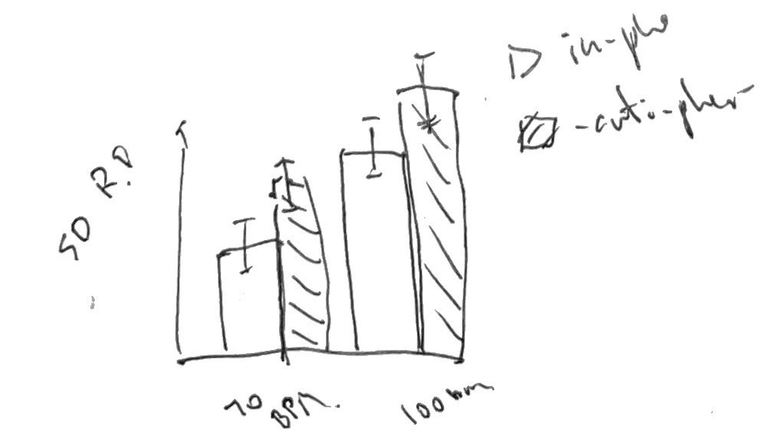

Question 4) Does the result support your initial hypothesis about the strength of coordination? Describe your results here to address this hypothesis.
_____________________________________________________________________________________
_____________________________________________________________________________________
_____________________________________________________________________________________
_____________________________________________________________________________________
____________________________________________________________________________________

Demo 2: Inter-personal coordination
You will repeat the same coordination paradigm with two participants. Each one would swing a pendulum in their wrist and try to coordinate with the other in two phase modes: in-phase and anti-phase.
Question 5) Hypothesis: Make a prediction about the effects of movement speed (frequency of pendulum oscillation) and nature of coordination (in- vs. anti-phase) on the stability of coordination and how the magnitude of relative phase standard deviation would compare to within-subject coordination.
_____________________________________________________________________________________
_____________________________________________________________________________________
_____________________________________________________________________________________
_____________________________________________________________________________________
____________________________________________________________________________________
Question 6) Using the data in Coord_Lab_data.xlsx Make two plots in excel illustrating the results for two participants. There should be two plots (one for each participant) showing the relative phase SD as a function of BPM and Type of coordination (in- vs. anti-phase)

Question 7) Does the result support your initial hypothesis about the strength of coordination? Describe your results here to address this hypothesis. Are the patterns of changes in the relative phase similar to the within-person demo results?
_____________________________________________________________________________________
_____________________________________________________________________________________
_____________________________________________________________________________________
_____________________________________________________________________________________
____________________________________________________________________________________

